**University of Prishtina “Hasan Prishtina”**

**Faculty of Electrical and Computer Engineering**



**Technical documentation of the project**

**Subject: Semantic Web**

**Project Title: Ontology Development for Knowledge Representation in Boxing Domain**

**Professors Students / email addresses**

|  |  |  |
| --- | --- | --- |
| Prof. Dr. Lule Ahmedi  Msc. Adrian Ymeri | 1. Uran Lajçi | [uran.lajci@student.uni-pr.edu](mailto:uran.lajci@student.uni-pr.edu) |
| 2. Elvir Misini | [elvir.misini@student.uni-pr.edu](mailto:elvir.misini@student.uni-pr.edu) |

Prishtinë, Kosovë, 2023

**Contents**

Abstract 5

1. Introduction 6

2. Background 7

2.1. The History of Boxing 7

2.2. Existing Boxing Ontologies 8

2.3. Towards a More Comprehensive Boxing Ontology 8

3. Methodology 9

4. The Boxing Ontology 10

4.1. Ontology Lexigon 10

4.2. Restrictions, Domains and Ranges of Object Properties 11

4.3. Validation of the Ontology 12

4.4. Ontology Graphs 13

5. Population of the domain ontology 14

5.1. Data and datasets 14

5.2. Individuals creation 15

6. SPARQL queries 17

7. SWRL rules 22

8. Conclusion 23

References 24

**Table of Figures**

Figure 1. Resasoner VIew. 12

Figure 2. CMD View of Reasoner. 12

Figure 3. Onto Graph of the Boxing ontology. 13

Figure 4. The view of cellfile. 15

Figure 5. Transformator Rule Editor with the written fields. 16

Figure 6. A added boxer individual. 16

Figure 7. Result of the query to get 10 boxers with the most wins. 17

Figure 8. Result of the query to get 10 boxers with the most losses. 17

Figure 9. Result of the query to get boxers grouped by residence. 18

Figure 10. Result of the query to get boxers grouped by division. 18

Figure 11. Result of the query to get 10 boxers with the most draws. 19

Figure 12. Result of the query to get the matches of Angel Fierro. 19

Figure 13. Boxers that have played in boxing matches. 20

Figure 14. Result of query to get the boxers that played in they're residence country. 21

**List of Tables**

Table 1. The Ontology Lexigon of the Boxing domain. 10

Table 2. Object properties. 11

Table 3. Boxer dataset. 14

Table 4. Boxing matches dataset. 14

**List of Abbreviations**

OWL Web Ontology Language

SPARQL SPARQL Protocol and RDF Query Language

BCE Before the Common Era

RDF Resource Description Framework

DSL Domain-Specific Language

SWRL Semantic Web Rule Language

WBA World Boxing Association

WBC World Boxing Council

IBF International Boxing Federation

DB Database

CMD Command Prompt

# Abstract

The Semantic Web represents the future of the internet, encompassing various domains, including sports. In this paper, our primary objective is to construct a comprehensive ontology for the boxing domain, addressing the lack of existing coverage in the Semantic Web. By utilizing Protege as our development tool, RDF and OWL as the language of representation, and employing SPARQL for querying and SWRL rules for inference, we aim to encapsulate the most significant information about boxing.

Our ontology serves as a foundational resource, facilitating information retrieval and analysis of diverse boxing data. It encompasses a wide range of boxing-related concepts, such as boxers, boxing games, styles, techniques, equipment. By providing structured and standardized information, our ontology enhances knowledge representation in the boxing domain, benefiting various stakeholders, including trainers, athletes, and promoters.

Moreover, the integration of SPARQL enables advanced query capabilities, allowing users to extract specific boxing-related information from large datasets. Furthermore, the incorporation of SWRL rules facilitates reasoning and inference, enabling automated deduction and knowledge discovery within the boxing domain.

By developing this ontology, we contribute to the advancement of the Semantic Web and knowledge representation in the sports domain. Our work establishes a foundation for a more comprehensive boxing ontology, fostering seamless integration and interoperability with other boxing-related applications and platforms.

**Keywords:** Ontology, Knowledge Representation, Semantic Web, Boxing Domain, SPARQL, SWRL, Protege, OWL, RDF

# 1. Introduction

Ontologies serve as formal representations of knowledge in specific domains, facilitating machine-processable specifications with well-defined meanings [1]. They find applications across various domains, including sports, such as boxing [2, 3]. This paper focuses on the development of a comprehensive boxing ontology, addressing the need for structured information within this domain.

The introduction provides an overview of the paper's structure and briefly introduces each section.

Section 2 (Background) consists of two sub-sections. Sub-section 2.1 discusses the history of boxing, providing a contextual understanding of the sport. Sub-section 2.2 explores existing boxing ontologies, highlighting any gaps or limitations in the representation of boxing-specific knowledge. This examination sets the stage for the development of our dedicated boxing ontology.

Section 3 (Methodology) outlines the methodology employed in this research. It describes the approaches, tools, and frameworks utilized for developing the boxing ontology, ensuring its accuracy and relevance in capturing the nuances of boxing knowledge.

Section 4 (The Boxing Ontology) delves into the details of the developed ontology. Sub-section 4.1, titled "Ontology Lexigon," provides an in-depth exploration of the classes, relationships, and properties included in the boxing ontology. Sub-section 4.2, titled "Restrictions, Domains and Ranges of Object Properties," describes the constraints and specifications applied to the object properties within the ontology. Sub-section 4.3, titled "Validation of the Ontology," discusses the validation techniques employed to ensure the ontology's correctness and consistency. Lastly, sub-section 4.4, titled "Views from the Protege," provides insights into the visualization and management of the boxing ontology using the Protege development tool.

Section 5 (Population of the domain ontology) showcases the practical application of the boxing ontology by incorporating real-world boxing information into the ontology. This section demonstrates the ontology's capability to handle real-world data and enhances its utility for information retrieval and analysis.

Section 6 (SPARQL queries) highlights the querying capabilities of the developed ontology using SPARQL. It demonstrates how users can retrieve specific information from the ontology, enabling efficient data analysis and knowledge extraction.

Section 7 (SWRL rules) explores the integration of SWRL rules into the boxing ontology. This section explains how these rules enable automated reasoning and inference, enhancing the ontology's capabilities for knowledge discovery and advanced reasoning within the boxing domain.

Finally, Section 8 (Conclusion) summarizes the main findings, contributions, and implications of the developed boxing ontology. It provides a concise overview of the achievements and potential applications of the ontology.

# 2. Background

## 2.1. The History of Boxing

Boxing is an ancient sport with roots dating back to antiquity. It was included in the earliest Olympic Games in Greece in 688 B.C.E., and it has a rich, varied history throughout different cultures and eras [4].

In its early stages, Greek boxing (also known as Pygmachia) had fewer rules compared to the modern sport. The fighters (known as Pygmachion) used soft leather thongs to bind their hands and wrists, providing minimal protection. The Romans later adopted the sport, modifying it into a much more brutal form of entertainment, where metal-studded cesti were used and bouts often ended in death [5].

Boxing faded after the fall of the Roman Empire but reemerged in 17th century England as bare-knuckle boxing or prizefighting. These fights were quite brutal, with no rounds, no weight classes, and no prohibition on hitting a downed opponent [6].

In 1867, the Marquess of Queensberry rules were established, which made boxing less brutal and more of a regulated sport. These rules, including the mandatory use of gloves, three-minute rounds, and a ten-second count for knockdowns, are still largely in use today [7].

The 20th century saw the rise of boxing as a professional sport, with boxing champions becoming global celebrities. The sport was divided into different weight categories, and organizing bodies like the World Boxing Association (WBA), the World Boxing Council (WBC), and the International Boxing Federation (IBF) were formed to regulate these professional bouts [8].

The development and incorporation of technology in boxing, such as video replay, punch stats, and high-speed cameras, has further enhanced the understanding and knowledge representation in the boxing domain [9].

To this day, boxing remains a popular sport worldwide. Its history is characterized by evolution in technique, equipment, and regulation, making it an interesting case study for ontology development.

## 2.2. Existing Boxing Ontologies

In the study of knowledge representation in the boxing domain, it is essential to consider the existing ontologies. Two notable instances include a boxer-focused ontology and the broader DBpedia ontology.

The ontology found at [10] is specifically tailored for representing knowledge about boxers. It consists of classes such as Boxer, Fight, BoxingRing, WeightClass, and Organization. The individuals in the Boxer class can possess properties including hasName, hasWeight, hasHeight, hasReach, hasWinRecord, and hasLossRecord, among others. The individuals in the Fight class may have properties like hasBoxer1, hasBoxer2, hasLocation, hasWinner, and hasDate. This ontology effectively organizes data related to the boxers themselves and their interactions in the ring.

DBpedia ontology, found at [11], represents a broader and more comprehensive approach. As part of the DBpedia project, which aims to extract structured content from Wikipedia, it houses a wide range of classes and properties, some of which pertain to the boxing domain. Classes may include Athlete, BoxingMatch, BoxingStyle, and BoxingLeague. Additionally, properties such as hasBoxer, opponent, hasOutcome, hasWeightClass, and hasTitle at stake may be found within the DBpedia ontology.

## 2.3. Towards a More Comprehensive Boxing Ontology

While these existing ontologies provide a significant basis for understanding the sport, they fall short in providing a comprehensive ontology for the boxing domain. Both ontologies have certain limitations in terms of depth and breadth. For instance, the boxer ontology focuses primarily on boxers and their fights, while the DBpedia ontology, although broad, may not cover all aspects unique to boxing in significant detail due to its wider focus on multiple disciplines.

In our work, we aim to develop an ontology that merges the strengths of these existing models and extends beyond them. We aim to capture not only the athletes, their characteristics, and fights, but also incorporate elements such as training regimens, media data, boxing styles, and techniques, regulatory bodies, significant historical and contemporary events, and other facets that form an integral part of the boxing world. This extensive approach will enable a more comprehensive representation of knowledge in the boxing domain, providing valuable insights for a range of applications from sports management to data analytics and beyond.

# 3. Methodology

Our methodology for developing an ontology in the boxing domain is based on principles outlined in "A Semantic Web Primer" by Grigoris Antoniou and Frank van Harmelen [12], along with Natalya F. Noy and Deborah L. McGuinness's work, "Ontology Development 101: A Guide to Creating Your First Ontology" [13]. Following their comprehensive guidelines, we adopted a series of methodological steps, each designed to ensure the ontology's completeness, consistency, and relevance within the context of our research objectives.

**Determine Scope:**

Firstly, we defined the scope of our ontology, specifying that the domain to be covered is boxing, with a particular emphasis on analyzing the impact of travel on game results. This focused scope and objective guide the development process of the ontology.

**Consider Reuse:**

The next step involved evaluating existing ontologies for potential reuse or for deriving insights. In this context, none of the existing ontologies were deemed suitable for reuse. However, two ontologies, specifically the "Boxer" ontology available at [10] and the ontology at [11], provided valuable perspectives.

**Enumerate Terms:**

We then identified key terms or concepts relevant to the boxing domain and our research objective. These include, but are not limited to, Person, Boxer, Referee, Judge, BoxingMatch.

**Define Taxonomy:**

Following this, we established a taxonomy of classes, representing the hierarchy and relational structure within the ontology. We identified Boxer as a parent class, with AmateurBoxer and ProfessionalBoxer as its subclasses.

**Define Properties:**

We defined properties to encapsulate relevant attributes and relationships. For example, the Boxer class contains properties like firstName, lastName, and age.

**Define Facets:**

Additional facets were specified to enhance the representation of classes and properties. These facets include cardinality constraints, required values, and relational characteristics among others.

**Define Instances:**

The next phase of our methodology involved populating the ontology with individual instances. These instances represent real-world entities and their attributes, including specific boxing matches, boxers, venues, and travel details.

**Check for Anomalies:**

Finally, a comprehensive review of the ontology was conducted to identify and rectify any inconsistencies, errors, or anomalies.

By applying this structured approach, inspired by leading works in ontology development, we have created a comprehensive boxing ontology. This ontology will facilitate nuanced analysis and a deeper understanding of the influence of travel on boxing match outcomes.

# 4. The Boxing Ontology

## 4.1. Ontology Lexigon

|  |  |  |
| --- | --- | --- |
| Class Hierarchies | Object Properties | Data Properties |
| Awards  Boxing_Awards  Hall_of_Fame  Boxing_Hall_of_Fame_Las_Vegas  International_Boxing_Hall_of_Fame  Best_Boxer_ESPY_Award  Fight_of_the_Year  ...  Competitons  Boxing_Competitions  Amatuer_Competitions  Olympic_Boxing  Commonwealth_Games  ...  Professional_Competitions  World_Boxing_Association  World_Boxing_Super_Series  ...  Equipment  Boxing_Equipment  Corner_Supplies  Shoes  Protective_Gear  Gloves  Hand_Wraps  Headgear  Mouthguars  Match  Boxing_Match  Media  Books  Documentaries  Movies  Video_Games  Organizations  Governing_Bodies  European_Boxing_Union  ...  Person  Athlete  Boxer  Amatuer_Boxer  Professional_Boxer  Commentator  Boxing_Commentator  ...  Rules  Boxing_Rules  Styles  Boxing_Styles  Techniques  Boxing_Techniques | commentatesBoxingMatch  fightsInAmatuerBoxingCompetition  fightsInProfessionalBoxingCompetition  followsBoxingRules  hasBoxingStyle  hasBoxingTechnique  hasBoxingTrainer  hasPhysician  hasReferee  hasWonAward  isAbout  participatesInMatch  sharesTechnique  usesBoxingEquipment | age  city  country  date  division  firstBoxer  firstName  fullName  gender  height  lastName  nationality  nrOfDraws  nrOfLosses  nrOfWins  reach  residence  result  secondBoxer  venue |

Table 1. The Ontology Lexigon of the Boxing domain.

## 4.2. Restrictions, Domains and Ranges of Object Properties

|  |  |  |
| --- | --- | --- |
| Domain | Object Property | Range |
| Boxing_Commentator | commentatesBoxingMatch | Boxing_Match |
| Amatuer_Boxer | fightsInAmatuerBoxingCompetition | Amatuer_Competitions |
| Professional_Boxer | fightsInProfessionalBoxingCompetition | Amatuer_Competitions |
| Boxing_Match | followsBoxingRules | Boxing_Rules |
| Boxer | hasBoxingStyle | Boxer_Styles |
| Boxer | hasBoxingTechnique | Boxing_Techniques |
| Boxer | hasBoxingTrainer | Boxing_Trainer |
| Boxing_Match | hasPhysician | Boxing_Physician |
| Boxing_Match | hasReferee | Boxing_Referee |
| Professional_Boxer | hasWonAward | Boxing_Awards |
| Media | isAbout | Boxer |
| Boxer | participatesInMatch | Boxing_Match |
| Boxer | sharesTechnique | Boxer |
| Boxer | usesBoxingEquipment | Boxing_Equpment |

Table 2. Object properties.

## 4.3. Validation of the Ontology

The ontology validation is done by using the Reasoner. We have used the HermiT 1.4.3.456 resoner that is provided in Protege.

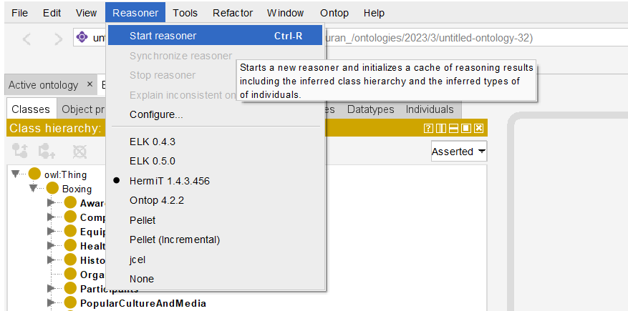

Figure 1. Resasoner VIew.

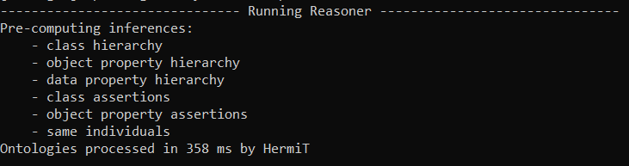

Figure 2. CMD View of Reasoner.

Our ontology does not show any conflicts, after we run the HermiT reasoner.

## 4.4. Ontology Graphs

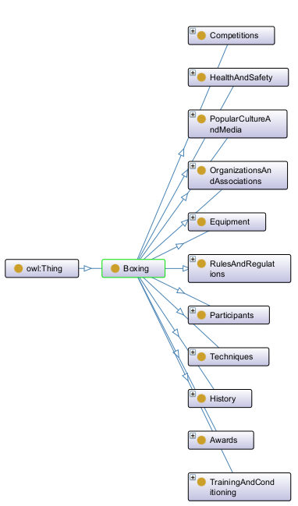

Figure 3. Onto Graph of the Boxing ontology.

# 5. Population of the domain ontology

## 5.1. Data and datasets

For boxers, boxing games and information about boxing there are some data that are formated in a dataset format. Here are some of the datasets that we found and used:

* Boxing Matches Dataset found on Kaggle [15]
* Boxing found on Kaggle [16]
* Undefeated Boxers [17]
* Boxing Data [18]
* Beautiful Soup Meets BoxRec [19]

Also we used public information about boxing that are posted in wikipedia, google and websites like BoxRec [20].

The data that are most used in our ontology are from Beautiful Soup Meets BoxRec. The datasets in Beautiful Soup Meets BoxRec are generated with web scraping by Stephen Plainte. For a comple guide in how are the datasets generated you can go to the website The Sweet Data Science by Stephen Plainte [21].

We have taken the datasets from the above databeses and websites but we have formated and cleaned them. So the boxers dataset has these attributes:

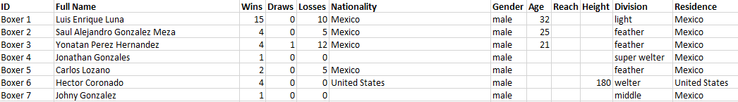

Table 3. Boxer dataset.

and the boxing matches dataset has these attributes:

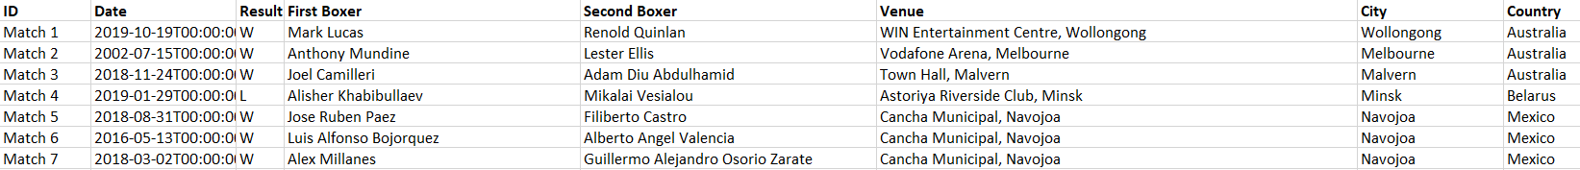

Table 4. Boxing matches dataset.

## 5.2. Individuals creation

For the population of the ontology we have used the Mapping Master DSL plugin. MappingMaster is a domain-specific language (DSL) that defines mappings from spreadsheet content to OWL ontologies. [14]

To get to the Cellfile in Protege we go to Tools => Create axioms from Excel Worksheet => we select the boxers.xls file. This sends us to the Cellfile window.

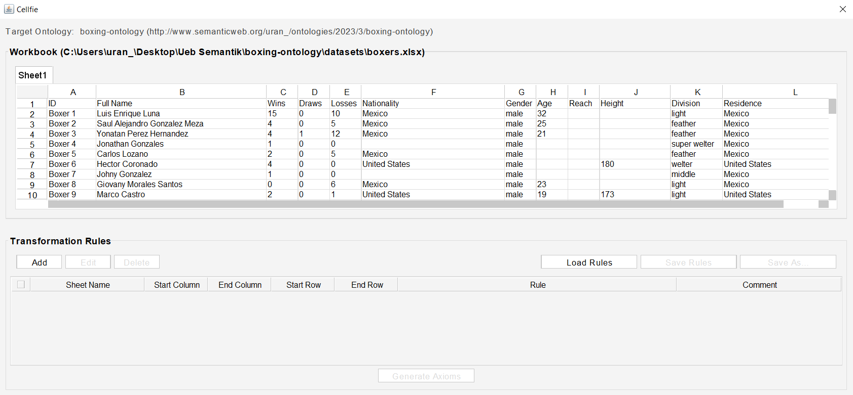

Figure 4. The view of cellfile.

In the cellfile we click in add to add the transformation rules. For the boxers we add this Transformation Rule to map the boxer information from the exel sheet to the Boxer entity, and get the individuals

{

"Collections": [

{

"sheetName": "Sheet1",

"startColumn": "A",

"endColumn": "L",

"startRow": "1",

"endRow": "1000",

"comment": "",

"rule": "Individual: @A*\nTypes: Professional_Boxer\nFacts: fullName @B*, nrOfWins @C*, nrOfDraws @D*, nrOfLosses @E*, nationality @F*, gender @G*, age @H*, reach @I*, height @J*, division @K*, residence @L*",

"active": true

}

]

}

In this way we can select the rows and columns we want.

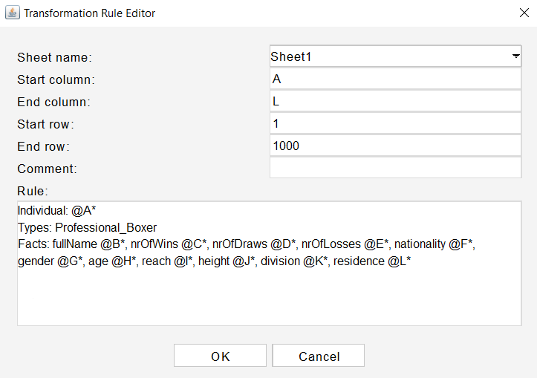

Figure 5. Transformator Rule Editor with the written fields.

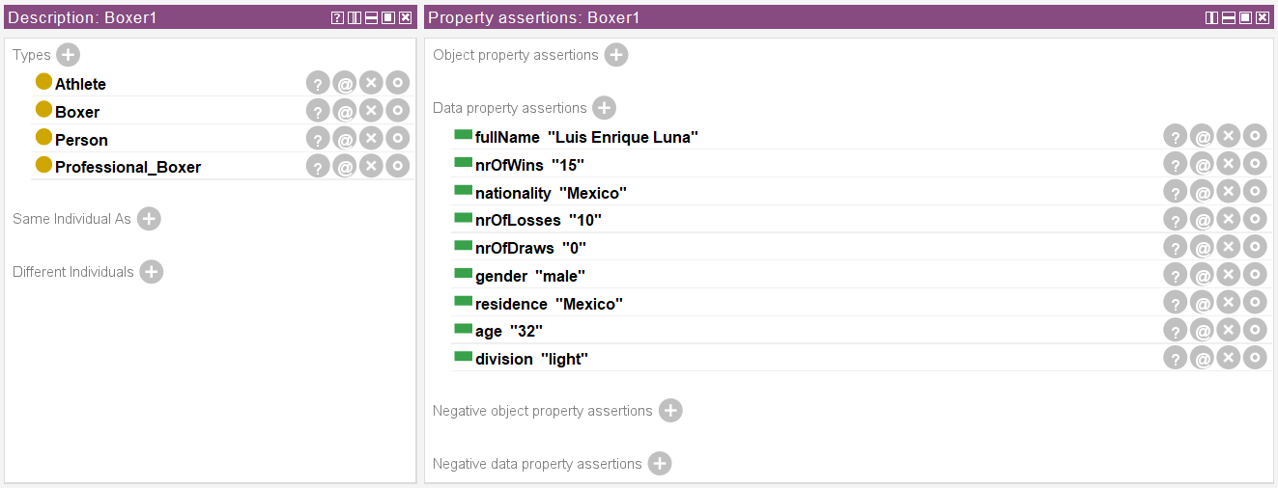

Figure 6. A added boxer individual.

# 6. SPARQL queries

**1. Query to get the top 10 boxers based on the number of their wins:**

PREFIX ns: <http://www.semanticweb.org/uran_/ontologies/2023/3/boxing-ontology#>

SELECT ?fullName ?wins

WHERE {

?boxer ns:fullName ?fullName ;

ns:nrOfWins ?wins .

}

ORDER BY DESC(?wins)

LIMIT 10

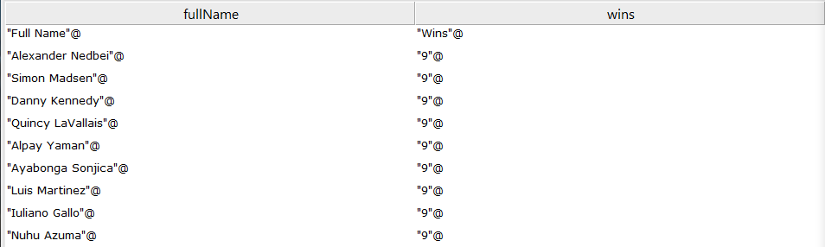

Figure 7. Result of the query to get 10 boxers with the most wins.

**2. Query to get the bottom 10 boxers based on the number of their losses:**

PREFIX ns: <http://www.semanticweb.org/uran_/ontologies/2023/3/boxing-ontology#>

SELECT ?fullName ?losses

WHERE {

?boxer ns:fullName ?fullName ;

ns:nrOfLosses ?losses .

}

ORDER BY ASC(?losses)

LIMIT 10

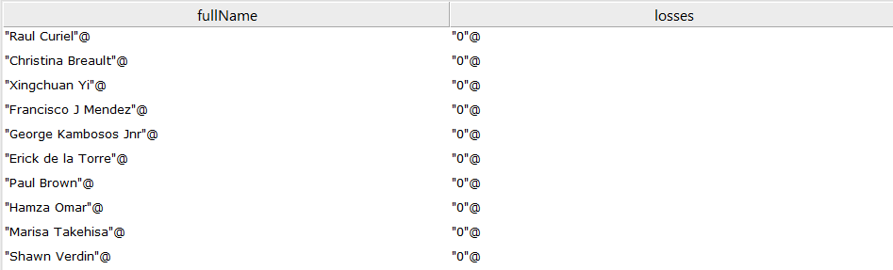

Figure 8. Result of the query to get 10 boxers with the most losses.

**3. Query to group boxers based on their residence:**

PREFIX ns: <http://www.semanticweb.org/uran_/ontologies/2023/3/boxing-ontology#>

SELECT ?residence (GROUP_CONCAT(?fullName; separator = ", ") as ?boxers)

WHERE {

?boxer ns:fullName ?fullName ;

ns:residence ?residence .

}

GROUP BY ?residence

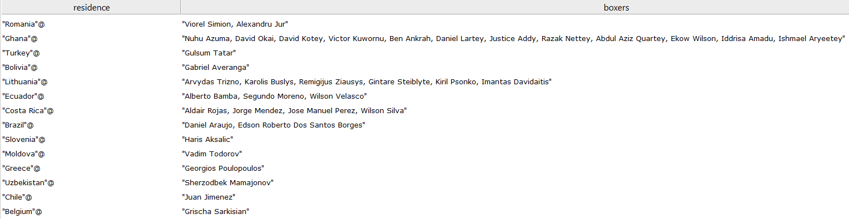

Figure 9. Result of the query to get boxers grouped by residence.

**4. Query to group boxers based on their division:**

PREFIX ns: <http://www.semanticweb.org/uran_/ontologies/2023/3/boxing-ontology#>

SELECT ?division (GROUP_CONCAT(?fullName; separator = ", ") as ?boxers)

WHERE {

?boxer ns:fullName ?fullName ;

ns:division ?division .

}

GROUP BY ?division

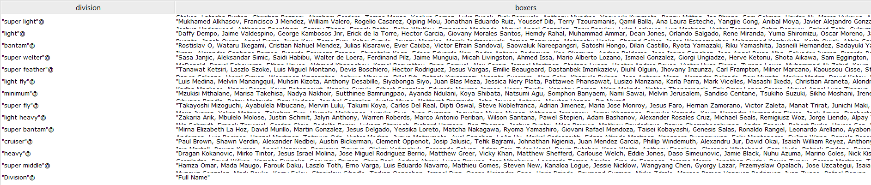

Figure 10. Result of the query to get boxers grouped by division.

**5. Query to get the boxers with the most draws:**

PREFIX ns: <http://www.semanticweb.org/uran_/ontologies/2023/3/boxing-ontology#>

SELECT ?fullName ?draws

WHERE {

?boxer ns:fullName ?fullName ;

ns:nrOfDraws ?draws .

}

ORDER BY DESC(?draws)

LIMIT 10

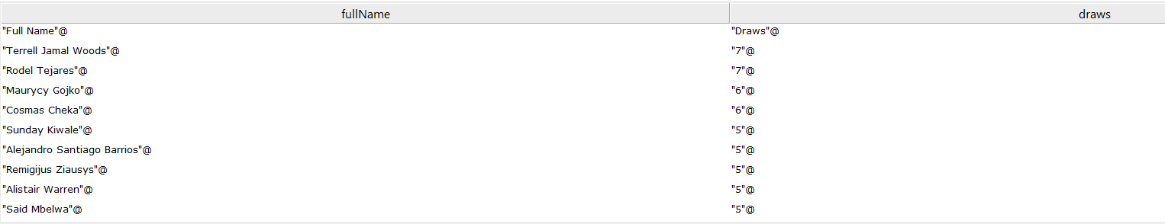

Figure 11. Result of the query to get 10 boxers with the most draws.

**6. This query will match any firstBoxer whose name contains "Angel Fierro", regardless of case. The "i" in the third argument of regex makes the matching case-insensitive.**

PREFIX ns: <http://www.semanticweb.org/uran_/ontologies/2023/3/boxing-ontology#>

SELECT ?firstBoxer ?secondBoxer ?venue ?date ?result

WHERE {

?match ns:firstBoxer ?firstBoxer ;

ns:secondBoxer ?secondBoxer ;

ns:venue ?venue ;

ns:date ?date ;

ns:result ?result .

FILTER regex(?firstBoxer, "Angel Fierro", "i")

}

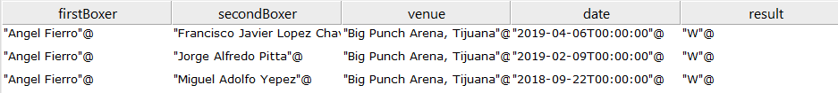

Figure 12. Result of the query to get the matches of Angel Fierro.

**7. SPARQL query that returns the full names of boxers from the Professional_Boxer class that appear in the Boxing_Match class as a firstBoxer or secondBoxer:**

PREFIX ns: <http://www.semanticweb.org/uran_/ontologies/2023/3/boxing-ontology#>

SELECT DISTINCT ?boxerName

WHERE {

?boxer ns:fullName ?boxerName .

{

?match ns:firstBoxer ?boxerName .

} UNION {

?match ns:secondBoxer ?boxerName .

}

}

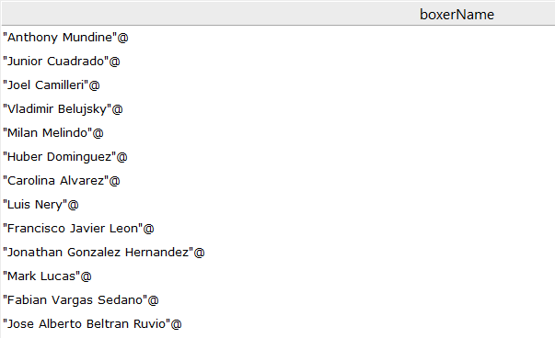

Figure 13. Boxers that have played in boxing matches.

**8. SPARQL query that can be used to find boxers whose residence is the same as the country where the match took place. This will be determined by comparing the residence of the Professional_Boxer and the country of the Boxing_Match.**

PREFIX ns: <http://www.semanticweb.org/uran_/ontologies/2023/3/boxing-ontology#>

SELECT DISTINCT ?boxerName ?residence ?matchCountry

WHERE {

?boxer ns:fullName ?boxerName ;

ns:residence ?residence .

{

?match ns:firstBoxer ?boxerName ;

ns:country ?matchCountry .

} UNION {

?match ns:secondBoxer ?boxerName ;

ns:country ?matchCountry .

}

FILTER(?residence = ?matchCountry)

}

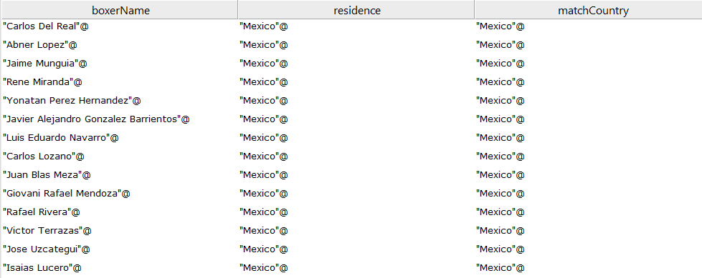

Figure 14. Result of query to get the boxers that played in they're residence country.

# 7. SWRL rules

# 8. Conclusion

# References

[1] P. Hitzler, M. Krotzsch, and S. Rudolph, Foundations of Semantic Web Technologies, p. 31.

[2] "DBpedia Ontology," [Online]. Available: <https://dbpedia.org/ontology/>.

[3] "W3C's List of Ontologies," [Online]. Available: <https://www.w3.org/wiki/Lists_of_ontologies>.

[4] J. R. Svinth, "Boxing in the Ancient World," in Britannica Online Encyclopedia, 2012. [Online]. Available: <https://www.britannica.com/sports/boxing>.

[5] D. Potter, Ancient Rome: A New History. Thames & Hudson, 2012.

[6] E. Gorn, The Manly Art: Bare-Knuckle Prize Fighting in America. Cornell University Press, 1986.

[7] K. Blady, The Jewish Boxers' Hall of Fame. SP Books, 1988.

[8] S. Assael, "Boxing in the Postmodern Age," in ESPN SportsCentury, 2005. [Online]. Available: <https://www.espn.com/sportscentury/features/00014063.html>.

[9] M. Woods, "Technological Change in Boxing: High-Speed Cameras and Punch Statistics," in The Sweet Science, 2014. [Online]. Available: <https://tss.ib.tv/boxing/articles-of-2014/19459-the-slow-motion-revolution>.

[10] "Boxer Ontology," [Online]. Available: <http://ontologydesignpatterns.org/ont/boxer/boxer.owl>.

[11] "DBpedia Ontology," [Online]. Available: <https://dbpedia.org/ontology>.

[12] G. Antoniou and F. van Harmelen, A Semantic Web Primer.

[13] N. F. Noy and D. L. McGuinness, "Ontology Development 101: A Guide to Creating Your First Ontology".

[14] "MappingMasterDSL," [Online]. Available: <https://github.com/protegeproject/mapping-master/wiki/MappingMasterDSL>.

[15] "Boxing Matches Dataset," [Online]. Available: <https://www.kaggle.com/datasets/iyadelwy/boxing-matches-dataset-predict-winner>.

[16] "Boxing Dataset," [Online]. Available: <https://www.kaggle.com/datasets/kirilspiridonov/boxing>.

[17] "Undefeated Boxers Dataset," [Online]. Available: <https://datahub.io/five-thirty-eight/undefeated-boxers>.

[18] "Boxing Dataset," [Online]. Available: <https://data.mendeley.com/datasets/vpbsd5bryy>.

[19] "BeautifulSoup Meets BoxRec," [Online]. Available: <https://github.com/FuriouStyles/BeautifulSoup_Meets_BoxRec>.

[20] "BoxRec," [Online]. Available: <https://boxrec.com/>.

[21] S. Plainte, "The Sweet Data Science," Medium, [Online]. Available: <https://medium.com/@stephenplainte/the-sweet-data-science-a260be7bf471>.